Project Information DAAssignment-3

**Team ID:** LTVIP2025TMID48627

**Team Size:** 4

**Team Leader:** Y Mahaboob Basha

**Team member:** Shamshunnisa Makam

**Team member:** Teneti Saranya

**Team member:** T Sri Kanth

ID: 22F21A3245

INSTITUTION: Gates Institute of Technology

Project Title: Measuring the Pulse of Prosperity: An Index of Economic Freedom Analysis

Dataset Link: <https://drive.google.com/file/d/1UmrCVmQFQYorNUTw414G3xot6rm46BwR/view>

¡]Visualization Screenshots

# 1. KPI-Focused Interface

Shows key metrics—Total Sales, Gross Income, Quantity—with trend indicators, gauges, and symbol charts. Great for a high-level snapshot of branch-wise performance.

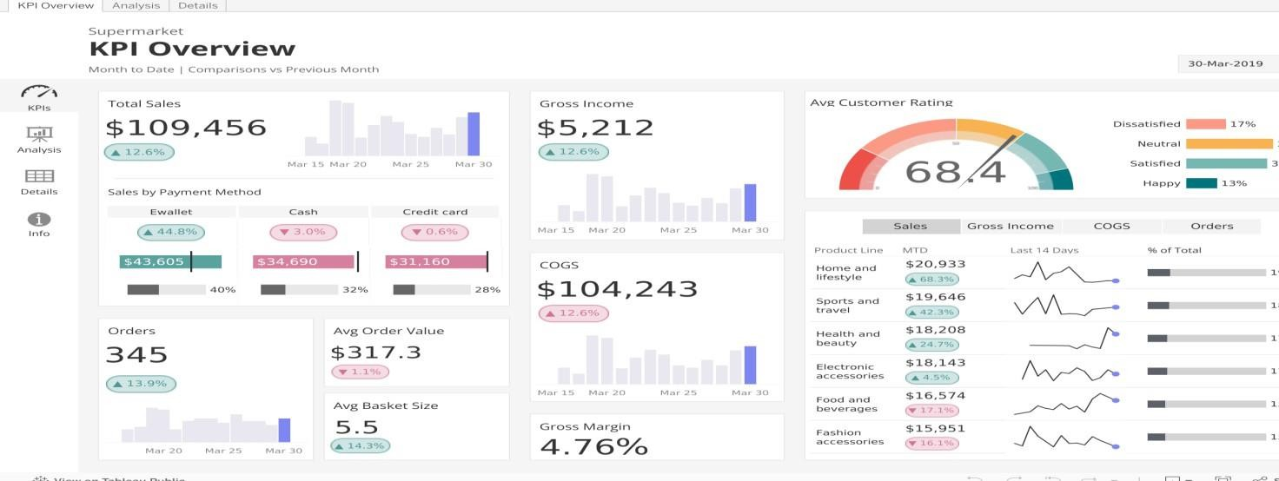

# 2. Multi-Component Retail Dashboard

Combines area charts, bar charts, and filterable lists in a clean layout. Offers dynamic filtering by branch, category, or time period.

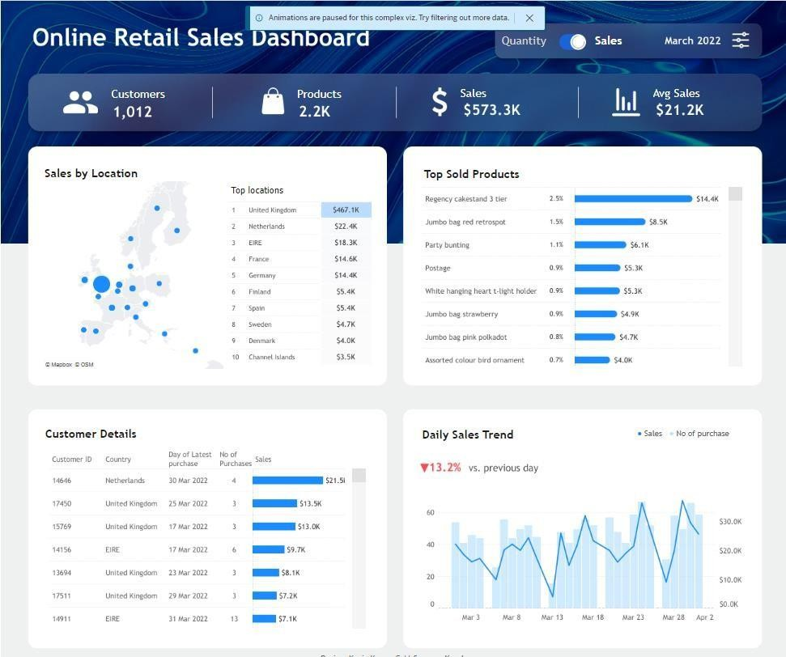

# 3. Time-Based Sales & Payments View

Includes monthly timelines with stacked bars and side panels for payment methods or product lines—ideal for trend and distribution analysis.

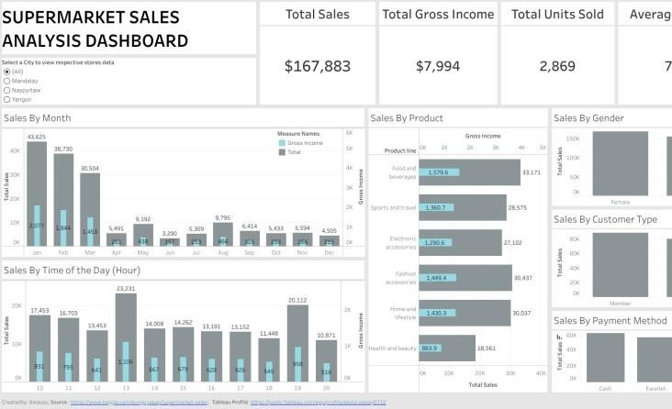

# 4. Dark-Themed Executive Dashboard

Features slick aesthetics with bar trends, KPIs, and product-level insights—perfect for management reporting.

